USING a DESKTOP or LAPTOP:
1. Go to gmail.com and login to your St. Damian email.
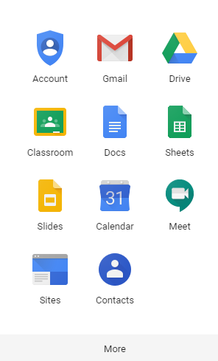
2. Once you have logged in, click on the grid of 9 boxes in the top right hand corner
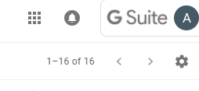
3. Click on the Classroom App. You may have to click on the “more” to get to more apps
4. Click “join class” or the + sign at the top right hand side of the screen.
* If you have already joined the class, click on your class.
* If you have NOT joined your class, you will be prompted to use a class code to get in to the class.
8th login code: txqtowj
7th login code: ys7kt1
5. Once you’re in the classroom you are looking at the STREAM or Dashboard page. This gives you messages and updates on what I have posted. To access homework click on the “classwork” on the bar on the top of the page. This will bring you to a page with all of your assigned work. If you click on your assignment, you will see a TURN IN button in the top right hand corner. WHEN YOU ARE DONE with your work, press this button.

